EMIS — UI/UX Design Documentation
Project title: Design and Development of a Privacy-Aware QR/NFC-Based Emergency Medical Information System
Design contributor/reviewer: Shugyla Akhit
Date: 23 October 2026
Repository: https://github.com/BekbolatSE2403/Diploma_work
Figma project: Link to Figma template

1. Project Overview
EMIS is a university diploma prototype designed to provide quick access to selected emergency medical information through a QR code or NFC medical ID card. The interface prioritizes clarity, accessibility, and limited disclosure of personal information.

2. Prepared Design Materials
Four Figma concepts have been prepared: a mobile emergency profile, a desktop emergency profile, a QR/NFC scanning journey, and a medical ID card concept. The designs demonstrate the proposed interface and navigation flow; they do not establish that QR/NFC functionality is operational.

3. Interface Structure
The emergency profile presents the patient’s name, critical allergies, reported blood type, medical conditions, emergency contact, and a Call 112 action for Kazakhstan. Allergy warnings are highlighted to support rapid identification. Both mobile and desktop layouts distinguish public emergency information from private records.

4. Visual Design and Usability
The visual concept uses navy typography, teal interface accents, light backgrounds, and red warning elements. Rounded cards and clear headings support quick scanning. The mobile layout uses a compact reading order, while the desktop layout separates medical information from emergency actions.

5. Privacy and Safety
The prototype uses fictional, self-reported information and includes notices that the details are not clinically verified. The proposed public profile contains only emergency-relevant information. Actual consent controls, data protection mechanisms, and backend integration remain outside the demonstrated design.

6. Review Findings and Next Steps
Before final approval, align the demo blood type across mobile and desktop screens (currently B+ and O+) and use the same fictional emergency contact (currently Batman and Sarah Johnson). Export all four frames, verify design specifications in Figma, add the project link, and review the documentation with the design contributor. The medical ID card currently contains a QR placeholder and conceptual NFC indication.

7. Visual references

Mobile emergency profile
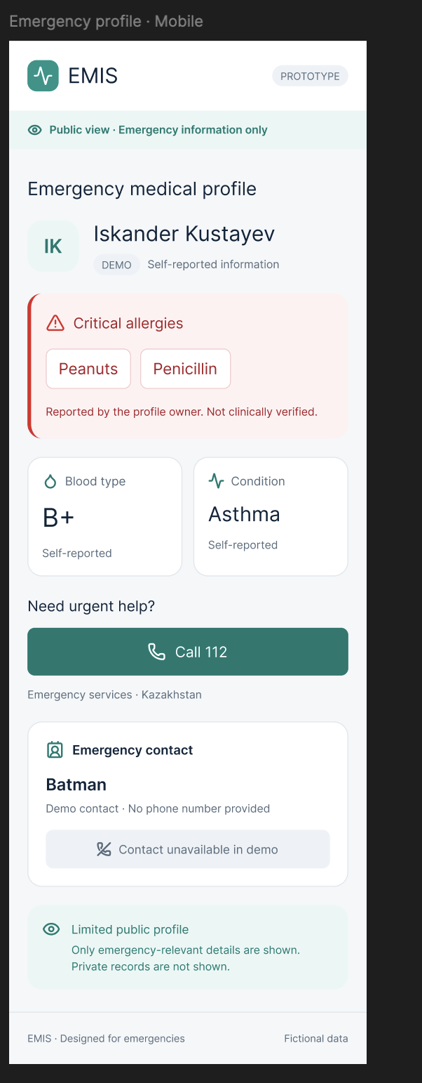

Desktop emergency profile and QR/NFC scanning journey
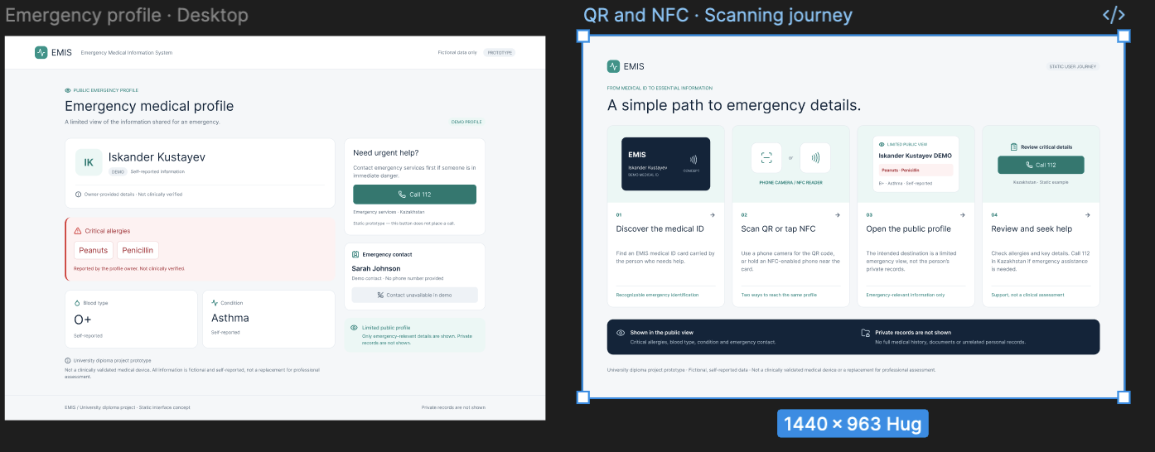

NFC medical ID card concept
